# Homework: HTML5 Tables

Please submit as homework a single zip archive holding the source code of all below described problems.

## Simple Table

Create an HTML page like the image below (100% accuracy is not required).



Hint: Use table for the layout. Link the Antra logo with <https://antra.net/>.

*Note: Using tables for creating website layout is deprecated; we use this approach only to practice the making of tables.*

## Exam Results

Create an HTML table like the image below (100% accuracy is not required). Use semantic table tags: **<thead>**, **<tfoot>**, **<tbody>**, etc.

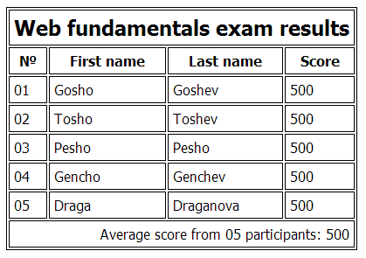

## Nested Tables

Create an HTML table like the image below by using nested table (100% accuracy is not required). Link the Antra logo with <https://antra.net/>. Make the link open in new tab.



## *Website Header

Create a Web page header that looks like the picture below (**100% accuracy is not required**). Use tables to achieve the layout. Use list for the menu. Use text input field and button for the search. Link the Antra logo with <https://antra.net/>. The menu buttons must work (open some URL). Making the menu with a dropdown functionality is optional. **You don't need to implement the same styles as the example.**



*Note: Using tables for creating website layout is not good practice; we use this approach only to practice the making of HTML tables.*

## Life in Antra

Create an HTML page like the image below (100% accuracy is not required). 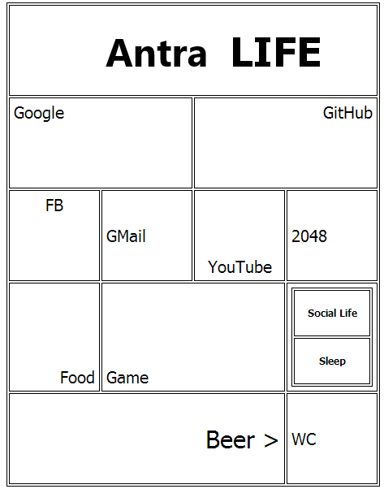

## ** "Life in Antra" Keyboard

Create an HTML page like the image below (100% accuracy is not required). The buttons must open web pages in new tab (by your choice). You can change the content of the buttons by your liking.

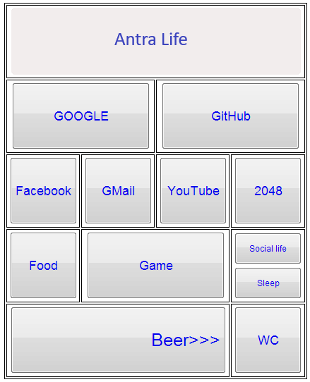

*Hint: Use tables and buttons.*

## ***Calculator

Create a simple **fully functional calculator**, similar to the image below. You can use styles by your liking.

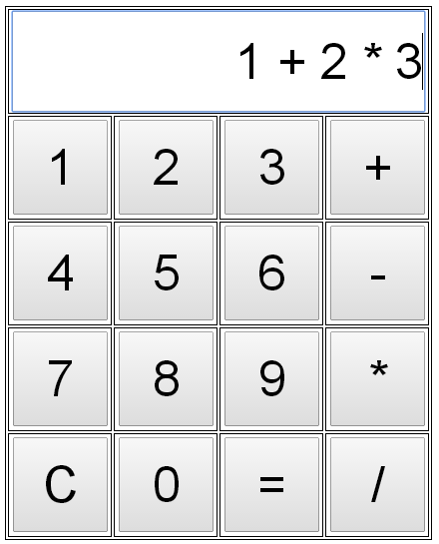

*Hint: Use JavaScript to achieve the functionality of the calculator. You may calculate the entered expression by the* ***eval(expression)*** *function in JavaScript.*